

SMART COMPILER WITH AI-BASED SYNTAX ERROR DETECTION AND AUTO CORRECTION
A CAPSTONE PROJECT REPORT
A Capstone Project Report submitted in partial fulfilment of the requirements
for the Course of
CSA1403 – COMPILER DESIGN
to the award of the degree of
BACHELOR OF TECHNOLOGY
IN
INFORMATION TECHNOLOGY
Submitted by
SELVA PRABHU A K (192421224)
K AVINASH (192411044)
Under the Supervision of
Dr. Michael. G
SIMATS ENGINEERING
Saveetha Institute of Medical and Technical Sciences
Chennai-602105
SEPTEMBER 2026

SIMATS ENGINEERING
Saveetha Institute of Medical and Technical Sciences
Chennai-602105

BONAFIDE CERTIFICATE
This is to certify that the Capstone Project entitled “Smart Compiler with AI-Based Syntax Error Detection and Auto Correction” has been carried out by Selva Prabhu A K (192421224) under the supervision of Dr. Michael. G and is submitted in partial fulfilment of the requirements for the current semester of the B.Tech Information Technology program at Saveetha Institute of Medical and Technical Sciences, Chennai.

COURSE COORDINATOR COURSE FACULTY

Dr. W. Deva priya Dr. G. Michael Professor Professor

Department of CSE Department Of CSE SIMATS Engineering, SIMATS Engineering,
SIMATS, Chennai – 602105. SIMATS, Chennai – 602105.

SIMATS ENGINEERING
Saveetha Institute of Medical and Technical Sciences
Chennai-602105

DECLARATION
We, Selva Prabhu A K of the Department of Information Technology, SIMATS Engineering, Saveetha Institute of Medical and Technical Sciences, Chennai, hereby declare that the Capstone Project Work entitled “Smart Compiler with AI-Based Syntax Error Detection and Auto Correction” is the result of our own bonafide efforts. To the best of our knowledge, the work presented herein is original, accurate, and has been carried out in accordance with the principles of engineering ethics and academic integrity. All sources, references, software libraries, external services, computational resources, and AI-assisted resources used during the project have been appropriately acknowledged. We further declare that the data, results, analysis, and findings presented in this report have not been fabricated, falsified, or manipulated. External AI services are disclosed wherever they materially contribute to the implementation or evaluation. We confirm that applicable ethical, academic, institutional, and professional requirements have been followed throughout the planning, implementation, testing, analysis, and documentation of the project.
Place: Chennai
Date: 07.09.2026

Signature of the Students with Names
A K Selva Prabhu (192421224)

SIMATS ENGINEERING
Saveetha Institute of Medical and Technical Sciences
Chennai-602105

Individual Contribution Statement
(Mandatory for all team projects)
Student Name /  Register No. | Specific Responsibilities | Design & Development Contribution | Testing & Analysis Contribution | Report Contribution | Approx.  Contribution (%)
Selva Prabhu A K  192421224 | Primary responsibility for Module 1 – Lexical & Syntax Analysis and local diagnostic workflow. | Implemented / integrated local syntax-oriented checking, bracket and string validation, selected language heuristics, editor error highlighting and diagnostic state handling. | Tested common structural faults, verified diagnostic locations/messages, and checked local-only behaviour without AI service. | Chapters 1 and 3 inputs; Module 1 implementation/testing sections; individual reflection; appendices related to local analysis. | 50%
K Avinash  192411044 | Primary responsibility for Module 2 – AI-Based Error Detection & Auto Correction. | Implemented / integrated Gemini API analysis, structured responses, auto-correction workflow, correction review, Diff Viewer and AI Tutor interaction. | Tested AI analysis, correction responses, diff review and integrated end-to-end behaviour. | Chapter 2 inputs; Module 2 implementation/testing sections; individual reflection; AI/API appendices. | 50%
Total |  |  |  |  | 100%

ABSTRACT
Traditional compiler interfaces generally provide syntax errors as messages, but beginners may find it difficult to understand the cause of an error and determine an appropriate correction. This project addresses that engineering problem by developing a web-based Smart Compiler that combines conventional local syntax-oriented checking with AI-assisted error explanation and automatic correction. The system accepts source code through an interactive browser interface, supports multiple language modes, performs fast local checks for common structural problems, and optionally sends source code and diagnostic context to the Gemini 2.5 Flash model through a Node.js and Express backend. The AI response is requested in a structured format containing validity status, summary, error location, severity, category, message, description, buggy snippet, suggested fix, corrected code, and an explanation of fixes. The application presents diagnostics in an error panel and provides Apply Fix, Fix All and Diff features so that proposed changes can be reviewed before the source is replaced. An AI Tutor function provides contextual explanation and pair-programmer style assistance. JavaScript has a lightweight client-side execution path and HTML has a preview path, while the backend provides AI-based execution simulation for other supported modes rather than invoking native compilers. The demonstration using an intentionally faulty Java InventoryManager program produced four visible syntax issues in the submitted interface. The prototype therefore demonstrates an integrated path from source entry and local checking to AI analysis, correction review and execution-related output. The principal engineering trade-off is between deterministic local analysis and the broader contextual capability of an external AI model. The main limitations are the absence of a complete parser/AST pipeline, native compilation for every language, persistent storage, a trained correction model, quantitative benchmark evaluation and production-grade secure execution isolation. Future development can address these limitations by integrating formal parsers, compiler toolchains, secure sandboxes, persistent project management, patch validation and labelled benchmark datasets.
Keywords: compiler design, syntax analysis, static checking, artificial intelligence, auto correction, Gemini API

TABLE OF CONTENTS
Sl. No. | Title | Page No
i | CERTIFICATE FROM THE SUPERVISOR | ii
ii | DECLARATION BY THE CANDIDATE | iii
iii | INDIVIDUAL CONTRIBUTION STATEMENT | iv
iv | ABSTRACT | v
v | LIST OF FIGURES | vi
vi | LIST OF TABLES | vii
vii | LIST OF ABBREVIATIONS / SYMBOLS | viii
1 | CHAPTER 1: Introduction | 1
2 | CHAPTER 2: Literature Review | 4
3 | CHAPTER 3: Engineering Design & Trade-offs, Sustainability, Ethics, Safety, Risk & Security | 7
4 | CHAPTER 4: Implementation, Testing & Results, Project Management | 13
5 | CHAPTER 5: Conclusion & Reflection | 20
 | REFERENCES | 22
 | APPENDICES | 23

LIST OF FIGURES
Figure No. | Figure Name | Page No.
3.1 | Actual implemented system architecture | 9
3.2 | Smart Compiler operational workflow | 9
3.3 | Module 1 – Local syntax-oriented checking flow | 10
3.4 | Module 2 – AI error analysis and auto correction flow | 11
4.1 | Faulty Java source code used in the demonstration | 15
4.2 | Syntax diagnostics and suggested fixes in the implemented interface | 16

LIST OF TABLES
Table No. | Table Name | Page No.
2.1 | Comparative Analysis | 5
3.1 | Stakeholder / User Requirements | 7
3.2 | Functional & Non-Functional Requirements | 7
3.3 | Constraints & Applicable Standards | 7
3.4 | Design Specifications | 8
3.5 | Alternative Solution Evaluation Matrix | 8
3.6 | Error Data Model | 11
3.7 | Trade-off Analysis | 12
3.8 | Sustainability, Ethics, Safety & Security Considerations | 12
3.9 | Risk Register | 12
4.1 | Development Approach & Resources
4.2 | Software Resources and Modern Tools | 13
4.3 | Test Plan & Verification | 16
4.4 | Specification-wise Results | 17
4.5 | Objective Achievement | 18
4.6 | Project Milestones | 18
4.7 | Project Roles and Contribution | 19
4.8 | Project Budget | 19
5 | Engineering Complexity Analysis | 23

LIST OF ABBREVIATIONS / SYMBOLS

Symbol | Description | Unit
AI | Artificial Intelligence | —
API | Application Programming Interface | —
AST | Abstract Syntax Tree | —
CSS | Cascading Style Sheets | —
DOM | Document Object Model | —
HTML | HyperText Markup Language | —
JSON | JavaScript Object Notation | —
JS | JavaScript | —
LLM | Large Language Model | —
NLP | Natural Language Processing | —
SQL | Structured Query Language | —
UI | User Interface | —
TS | TypeScript | —
UX | User Experience | —
HTTP | Hypertext Transfer Protocol | —
HMR | Hot Module Replacement | —
Vite | Frontend development/build tool | —

CHAPTER 1
INTRODUCTION AND ENGINEERING PROBLEM
1.1 Background
Compiler design is the study of methods used to transform source programs into forms that can be processed, executed or further translated by a computing system. A conventional compiler front end typically includes lexical analysis and syntax analysis before later stages such as semantic checking, intermediate representation and optimization. Lexical analysis identifies meaningful token classes from character sequences, while syntax analysis checks whether the resulting sequence follows the grammar of the language. These stages are important because errors detected early can prevent invalid source programs from progressing to later compilation stages.
In practical programming environments, compiler feedback is often presented through an editor or terminal as short diagnostic messages. Although such messages can be technically correct, a learner may still need to interpret the message, locate the relevant source statement, understand the rule that was violated, and decide how to correct it. When several syntax errors occur together, the debugging process can become repetitive and time-consuming.
The Smart Compiler project extends this traditional workflow by combining a local syntax-oriented diagnostic layer with an AI assistance layer. The local layer provides deterministic checks for common structural problems, while the AI layer uses surrounding source context to explain errors and propose corrections. The result is an interactive educational prototype rather than a replacement for a complete industrial compiler.
1.2 Need for the Project
The need for the project arises from the difference between detecting an error and helping a programmer understand and repair that error. A traditional diagnostic may indicate that a delimiter is missing, but a beginner may not immediately know which delimiter is expected or whether the error was caused by an earlier unmatched construct. An intelligent assistant can use the surrounding statements to produce a more contextual explanation and a candidate repair.
The problem affects students and beginner programmers most strongly because they are still learning language grammar, compiler terminology and debugging strategies. It can also affect experienced programmers during rapid prototyping when several edits introduce small structural faults. Existing rule-based linters are efficient for known patterns but require explicit rules, whereas AI systems can reason over a larger source context but may produce suggestions that need verification.
The engineering significance is therefore the design of a hybrid system that preserves the predictable behaviour of local checks while using AI selectively for contextual explanation and correction. The design must also consider API availability, latency, response structure, privacy of source code, correction safety, usability and the distinction between simulated and real execution.
1.3 Problem Statement
The engineering problem addressed by this project is the design of an interactive compiler-assistance system that can identify common syntax-level faults, provide location-aware and understandable diagnostics, use AI to interpret the surrounding code and recommend corrections, and allow the user to review proposed changes before applying them. The solution must operate under realistic constraints including limited implementation time, multiple language modes, external AI-service dependency, unpredictable AI output, protection of API credentials, and the need to avoid presenting simulated execution as actual compilation.
1.4 Project Aim
To design and implement a web-based Smart Compiler prototype that integrates deterministic local syntax-oriented checking with AI-assisted error detection, explanation and auto-correction, thereby improving the clarity and usability of compiler feedback for programming learners and developers.
1.5 Project Objectives
- To design an interactive browser-based source-code editor with language selection, diagnostic display and compiler-oriented actions.
- To implement a local syntax-oriented analysis module capable of identifying common structural faults such as unmatched brackets and unclosed strings, together with selected language-specific heuristics.
- To integrate a backend AI service capable of analysing source code and returning structured syntax diagnostics with line, column, severity, category, explanation and suggested correction.
- To develop an auto-correction workflow that generates corrected source code and a human-reviewable change summary.
- To provide a Diff Viewer and user-controlled Apply Fix / Fix All operations so that AI-generated changes are not silently imposed.
- To provide contextual explanation through an AI Tutor interface and execution-related output for supported language modes.
- To verify the prototype using intentionally faulty source programs and document functional results, engineering trade-offs and limitations.
1.6 Scope
The project includes a web-based code editor, selectable language modes, local structural checking, AI syntax analysis, AI correction, change review, contextual explanation, preset snippets, undo/redo support, diagnostic highlighting and execution-related output. The interface exposes ten language modes: JavaScript, TypeScript, Python, C++, Java, Rust, Go, SQL, HTML/CSS and JSON. The implementation README identifies eight core programming/SQL modes and provides HTML/CSS and JSON as additional modes.
The scope excludes a complete compiler front end, formal parser-generator integration, full semantic analysis, optimization, persistent database storage, authentication, collaborative editing and native compilation for every language. The current implementation also does not include a hardened server-side sandbox for arbitrary source execution. Non-JavaScript execution is represented through an AI simulation endpoint; therefore its output must not be interpreted as proof that the corresponding source was actually compiled and executed by a native toolchain.
1.7 Assumptions and Boundary Conditions
- The user provides syntactically meaningful source code and selects the language mode that best matches the code.
- The Gemini API key, when AI functionality is required, is configured on the backend rather than exposed directly in the browser.
- Local diagnostics remain available even when the external AI service is unavailable.
- AI-generated corrections are treated as suggestions and are reviewed by the user before application.
- The prototype is intended for educational and demonstration use rather than deployment as a secure public code-execution service.
1.8 Expected Engineering Outcome
The expected outcome is a functional software prototype that demonstrates a complete feedback loop: source entry, local checking, AI analysis, correction generation, review, application and execution-related output. The system is intended to show how compiler-design concepts can be integrated with modern AI capabilities while maintaining a clear separation between deterministic checks and probabilistic AI assistance.

CHAPTER 2
LITERATURE REVIEW AND EXISTING SOLUTIONS
2.1 Review Method
The literature review was conducted by identifying foundational compiler-design references, software engineering guidance relevant to the implementation technologies, and official documentation for the AI service and frontend framework. The review focused on lexical and syntax analysis, compiler diagnostics, rule-based static checking, AI-assisted programming, structured AI output and component-oriented web application design. Standards and security guidance were included where they directly influenced design decisions.
The review was deliberately limited to technologies and methods that have a clear relationship with the implemented system. Rather than claiming that every category of compiler technology was implemented, the review was used to distinguish the theoretical compiler pipeline from the lightweight syntax-oriented prototype.
2.2 Review of Existing Work
2.2.1 Compiler Front-End Principles
Aho et al. describe lexical analysis and syntax analysis as fundamental components of compiler construction. Lexical analysis maps character sequences to tokens, while syntax analysis determines whether token sequences conform to a grammar [1]. Cooper and Torczon similarly emphasize practical engineering considerations in compiler construction, including the interaction between correctness, implementation complexity and target requirements [2]. These principles support the use of a deterministic first-line diagnostic mechanism in the proposed system.
2.2.2 Rule-Based Linters and Static Checking
Rule-based static analysis is effective when faults can be described through deterministic patterns. Bracket matching, unterminated strings and selected language conventions are examples where a lightweight scan can provide immediate feedback without requiring an external service. The main limitation is coverage: a heuristic checker can only detect the patterns for which rules have been implemented and may not correctly represent the full grammar of a language.
2.2.3 AI-Assisted Code Analysis
Large language models provide a different form of code assistance because they can consider a wider source context and generate natural-language explanations. This makes them useful for tasks such as explaining an error, suggesting a repair or rewriting a code fragment. However, generated code is not guaranteed to be correct, and model responses may vary with context and prompt formulation. The proposed design therefore treats AI as an assistance layer and places a review step between generated corrections and source replacement.
2.2.4 Structured AI Responses
The Gemini API provides structured output capabilities in which model responses can be constrained using a JSON schema [5]. This is particularly suitable for compiler-style diagnostics because the interface requires consistent fields. In the implementation, the analysis endpoint requests fields such as isValid, summary, error identifiers, line, column, severity, category, message, description, buggySnippet, suggestedFix, correctedCode and explanationOfFixes. The correction endpoint similarly returns corrected source, line-level changes and a summary.
2.2.5 Component-Based Web Interfaces
React promotes component-based user interfaces in which application functionality can be separated into reusable components [3]. The implementation uses this principle to isolate the code editor, header controls, error panel, execution terminal, Diff Viewer, preset selector and AI Tutor. Vite provides the frontend development and build workflow [4]. Express is used to expose the backend API endpoints and connect the application to the AI service.
2.2.6 Existing Commercial / Practical Approaches
Modern integrated development environments and code editors commonly provide syntax highlighting, diagnostics, linting, formatting and sometimes automated code actions. Dedicated AI coding assistants additionally provide explanation and code generation. These approaches demonstrate that compiler feedback and AI assistance can coexist, but a compact educational prototype still benefits from explicitly exposing the stages so that learners can see the relationship between source code, diagnostic reasoning and correction.
2.3 Comparative Analysis
Existing Approach | Advantages | Limitations | Relevance to Proposed Work
Traditional compiler diagnostics | Deterministic, fast and grammar-driven | Messages may be terse; correction remains manual | Provides the conceptual foundation for error detection.
Rule-based linter | Fast and can work offline | Limited to explicitly implemented rules | Implemented as the local diagnostic layer.
IDE/editor diagnostics | Integrated with development workflow | Coverage depends on language/toolchain | Motivates location-aware editor feedback.
AI coding assistant | Contextual explanation and repair | May generate incorrect or unnecessary changes | Used for contextual analysis and correction.
Proposed hybrid Smart Compiler | Combines local checks, AI explanation and reviewable correction | External-service dependency and prototype boundaries | Selected as the integrated project approach.
Table 2.1 : Comparative Analysis
2.4 Research / Engineering Gap
The unresolved engineering gap is the integration of fast deterministic syntax-oriented feedback with contextual AI reasoning in a single beginner-oriented workflow. A purely local checker cannot easily provide broad natural-language explanations without adding extensive rules, while a purely AI-driven checker introduces uncertainty even for simple structural errors. The proposed system addresses this gap through a layered design: local checks provide an immediate baseline and AI analysis adds contextual explanation and correction when available.
2.5 Proposed Contribution
The project contributes an educational prototype with two clearly assigned technical modules. Module 1, owned primarily by Selva Prabhu A K, provides the local lexical-context and syntax-oriented checking path. Module 2, owned primarily by K Avinash, integrates Gemini-based error analysis and auto-correction. The team integrates both modules through shared diagnostic state and a user interface that allows errors and proposed corrections to be inspected in one workflow.

CHAPTER 3
ENGINEERING DESIGN & TRADE-OFFS, SUSTAINABILITY, ETHICS, SAFETY, RISK & SECURITY
3.1 Requirements
Stakeholder / User Requirements
Stakeholder | Requirement
Student / Beginner Programmer | Understand what an error means, where it occurs and how it may be corrected.
Programming Learner | Receive fast feedback without waiting for an external AI response for every basic structural fault.
Developer / Project Team | Maintain a modular implementation with separated UI, local analysis, backend API and AI integration.
Faculty / Evaluator | Demonstrate compiler-design principles through a working and explainable prototype.
Privacy-conscious User | Avoid exposing API credentials and understand that AI-enabled analysis may transmit source code to an external service.
Table 3.1 : Stakeholder / User Requirements
Functional & Non-Functional Requirements
Requirement | Type (Functional/Non-Functional) | Measurable Target
Edit and load source code | Functional | Source can be entered or loaded in the editor.
Select language mode | Functional | Ten selectable modes are available in the UI.
Run local checks | Functional | Common bracket/string and selected heuristic faults produce diagnostics.
Analyze with AI | Functional | Structured AI diagnostics are returned when API service is configured.
Auto-correct | Functional | Corrected source and change summary are returned.
Review changes | Functional | Diff Viewer presents original and corrected versions before application.
Explain code / errors | Functional | AI Tutor and explanation endpoint provide contextual responses.
Execution-related output | Functional | JavaScript/HTML paths and AI simulation output are displayed.
Availability | Non-Functional | Local diagnostics continue without an AI key.
Credential protection | Non-Functional | Gemini API key is read server-side from environment configuration.
Maintainability | Non-Functional | UI features and backend responsibilities are separated into components/endpoints.
Input handling | Non-Functional | Express JSON request size is limited to 5 MB.
Table 3.2 : Functional & Non-Functional Requirements

3.2 Constraints & Applicable Standards
Standard / Code | Requirement | How Applied in This Project
ISO/IEC 25010:2023 | Quality model for software products | Used as a quality checklist for usability, reliability, maintainability and security considerations.
OWASP Top 10:2021 | Awareness of common web application risks | Used to structure discussion of API credentials, input handling and unsafe execution concerns.
JSON Schema | Predictable structured data exchange | Used for Gemini diagnostic and correction responses.
ECMAScript / JavaScript language rules | Correct syntax for JavaScript mode | Relevant to editor examples and client-side execution path.
Institutional academic integrity requirements | Accurate acknowledgement of tools and external resources | AI service, software libraries and project resources are disclosed in the report.
Table 3.3 : Constraints & Applicable Standards

3.3 Design Specifications
Parameter | Target/Requirement | Unit | Priority
Frontend framework | React with TypeScript | application | High
Build tool | Vite development/build workflow | tool | High
Backend | Node.js + Express | service | High
AI model | Gemini 2.5 Flash | model | High
Structured AI response | JSON schema based | response | High
Request size limit | Express JSON limit | 5 MB | Medium
Default server port | Application server | 3000 | Medium
Supported UI language modes | Ten selectable modes | modes | Medium
Local linter complexity | Single-pass style checks where applicable | O(n) | High
Correction review | Diff before apply | workflow | High
Table 3.4 : Design Specifications

3.4 Alternative Solutions & Evaluation
Alternative 1: A purely rule-based parser and linter could provide deterministic diagnostics without external AI dependency. It would require substantially more grammar implementation to support multiple languages accurately.
Alternative 2: A purely AI-based analyzer could be developed quickly and would provide contextual explanations, but it would reduce determinism for simple structural faults and increase dependence on network availability.
Alternative 3: The selected hybrid approach combines a lightweight local diagnostic baseline with AI-assisted contextual reasoning and reviewable correction.
Criterion | Weight | Alternative 1  Rule-based | Alternative 2  AI-only | Alternative 3  Hybrid
Performance | 0.25 | 5 | 4 | 5
Cost | 0.15 | 5 | 3 | 4
Safety / Predictability | 0.25 | 5 | 2 | 4
Sustainability | 0.10 | 5 | 3 | 4
Reliability | 0.25 | 5 | 3 | 4
Overall suitability | 1.00 | 5.00 | 2.90 | 4.35
Table 3.5 : Alternative Solution Evaluation Matrix

The matrix is a design evaluation, not a measured benchmark. A score of 5 represents the strongest relative suitability against the criterion. The hybrid approach scores well because it avoids unnecessary AI calls for simple local checks while still providing contextual reasoning when required.
3.5 Selected Design & Detailed Design
The selected design is justified by the evaluation matrix: local checking provides high performance and predictability, while AI adds contextual reasoning without requiring the team to implement a complete natural-language explanation engine. The correction path is deliberately separated from analysis so that the user can inspect proposed changes before they affect the original source.
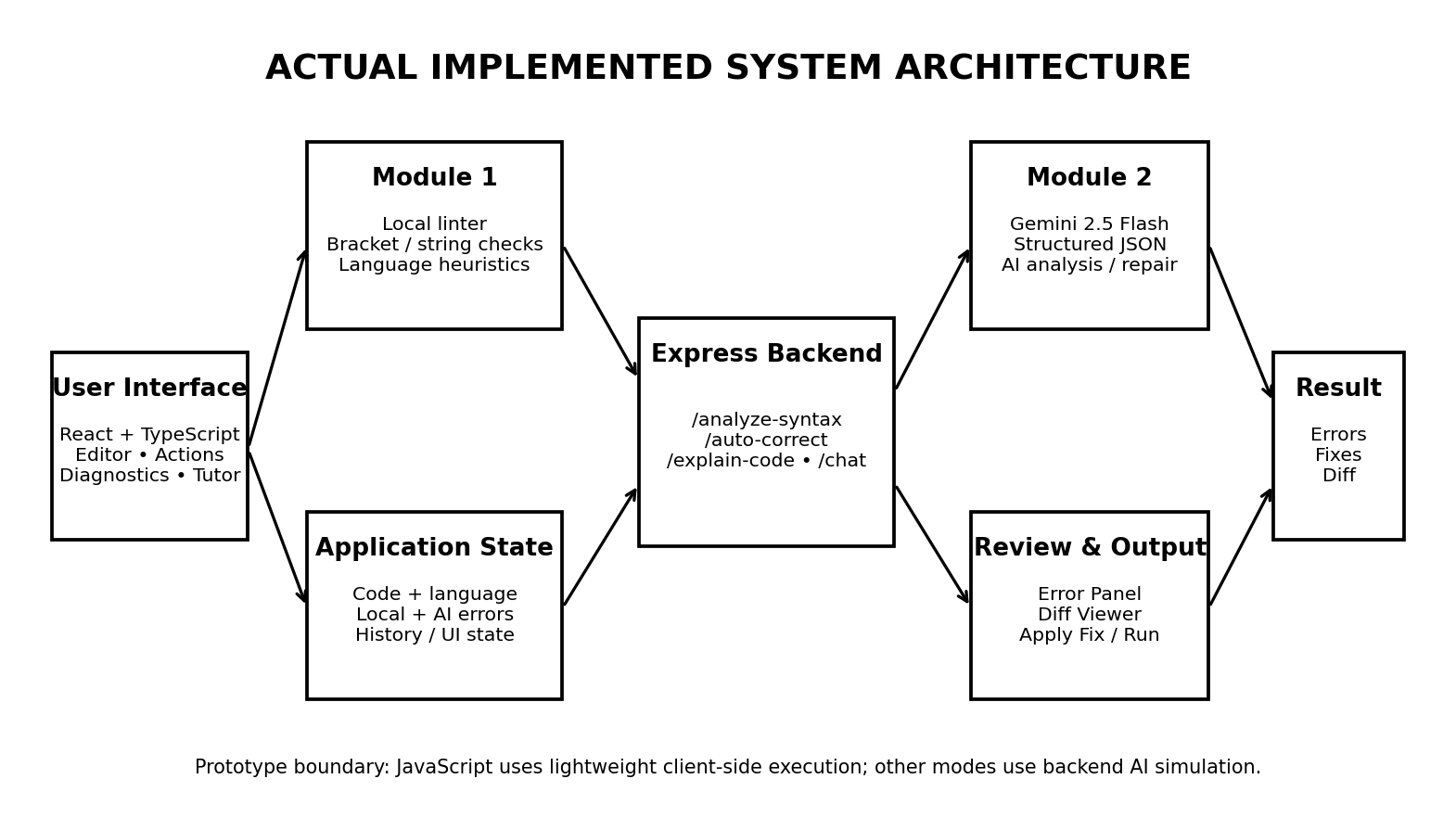
Figure 3.1 : Actual implemented system architecture
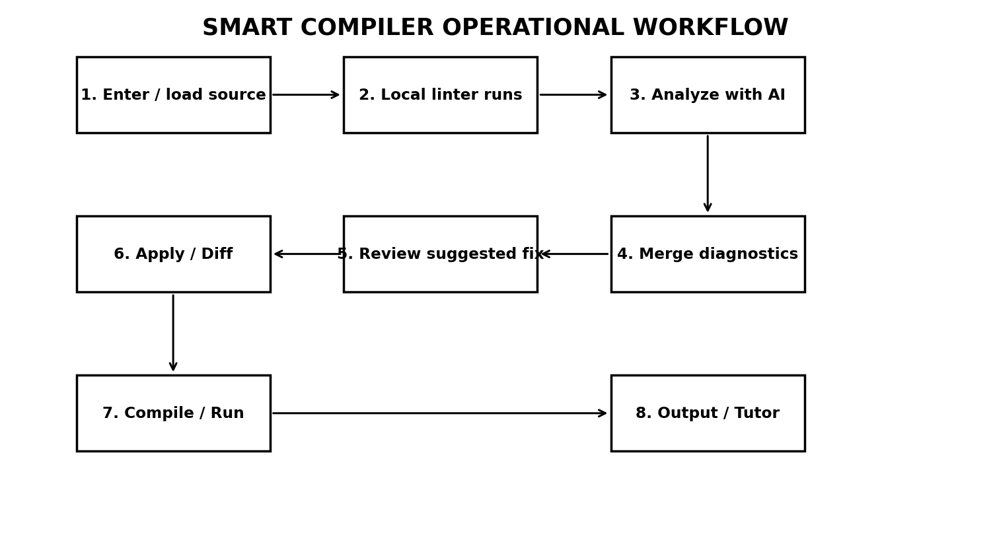
Figure 3.2 : Smart Compiler operational workflow
Systems approach: the user interface supplies source code and language context to the application state. The local linter produces deterministic diagnostics, while the Express backend handles AI-enabled requests. The AI service returns structured analysis that is merged with local diagnostics and rendered in the editor and error panel. Correction results pass through a review stage before the user applies changes.
3.5.1 Module 1 Detailed Design
Module 1 is primarily assigned to Selva Prabhu A K. The prototype implementation does not contain a complete compiler lexer/parser library; instead, it implements a lightweight local analysis engine. The engine scans source while considering language-specific comment forms, tracks opening and closing delimiters, detects unclosed string literals and applies selected language heuristics. Each detected problem is represented as a diagnostic with location and message information so that the editor can highlight the relevant source area.
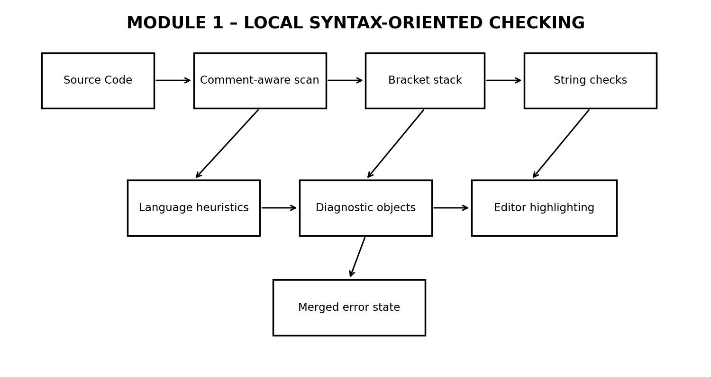
Figure 3.3 : Module 1 – Local syntax-oriented checking flow
3.5.2 Module 2 Detailed Design
Module 2 is primarily assigned to K Avinash. The backend lazily initializes a GoogleGenAI client using the GEMINI_API_KEY environment variable. The analysis endpoint sends source code and language information to Gemini 2.5 Flash with a system instruction that frames the model as a compiler/static analyzer. The response is constrained by a structured schema so that the frontend receives predictable fields.
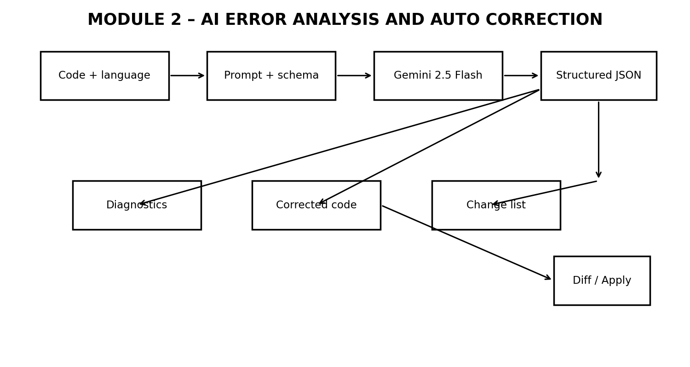
Figure 3.4 : Module 2 – AI error analysis and auto correction flow
3.5.3 API and Data Flow
The Express backend exposes GET /api/health and POST endpoints for /api/analyze-syntax, /api/auto-correct, /api/explain-code, /api/chat and /api/simulate-execution. The analysis endpoint receives source code and language, requests structured diagnostics and returns corrected code and an explanation. The auto-correct endpoint receives the current code and the specific errors and returns a proposed corrected version plus a list of changes. The application state then updates the diagnostics and opens the Diff Viewer where appropriate.
3.5.4 Error Data Model
Field | Purpose | Example / Type
id | Unique identifier for a diagnostic | string
line | Source line containing the issue | integer
column | Approximate source column | integer
severity | Importance of the issue | error / warning / info
category | Type of diagnostic | syntax / lexical / other
message | Short diagnostic message | string
description | Contextual explanation | string
buggySnippet | Relevant source fragment | string
suggestedFix | Candidate correction | string
correctedCode | Full corrected source when available | string
Table 3.6 : Error Data Model

3.5.5 Engineering Complexity
For a source file of n characters, the local scan is designed around sequential inspection and delimiter tracking, giving approximately O(n) time for the dominant scan and O(b) auxiliary memory where b is the maximum number of simultaneously open brackets. Language-specific heuristics add bounded additional passes or pattern checks. AI analysis complexity is not represented by a fixed algorithmic Big-O in this report because it depends on the external model service, input token length, network latency and service-side processing.
3.6 Trade-off Analysis
Design Decision | Alternative Considered | Benefit | Disadvantage | Final Decision & Justification
Local + AI analysis | AI-only | Fast baseline plus contextual reasoning | Two result sources must be merged | Selected because common faults remain available without AI.
Structured JSON output | Free-form AI text | Stable fields for UI rendering | Schema must be maintained | Selected because diagnostics require predictable fields.
Diff before auto-apply | Immediate replacement | User can inspect changes | Adds one interaction step | Selected to reduce unintended code changes.
AI execution simulation | Native compiler processes | Simple multi-language demonstration | Not equivalent to actual compilation | Accepted only as a documented prototype boundary.
Server-side API key | Browser-side key | Reduces direct credential exposure | Backend configuration required | Selected for safer credential handling.
Table 3.7 Trade-off Analysis

3.7 Sustainability, Ethics, Safety, Risk & Security
Domain | Consideration | Evidence Evaluated | Impact on Final Decision
Sustainability | Avoid unnecessary external AI requests for simple faults. | Local linter runs independently. | Hybrid architecture retained to reduce avoidable AI usage.
Ethics | AI-generated changes may be wrong and must remain reviewable. | Diff Viewer and Apply Fix workflow. | No silent replacement of source code.
Health & Safety | Software-only project; no physical hazards or dangerous fabrication. | No physical equipment or hazardous process involved. | Physical safety controls not applicable.
Security | Source code and credentials require protection. | Backend environment variable for API key; documented external-service boundary. | Credentials are not intentionally exposed in the frontend.
Privacy | Source submitted for AI analysis may be transmitted to an external service. | External Gemini API is used for AI features. | Users should avoid sending secrets or confidential code.
Table 3.8 : Sustainability, Ethics, Safety, Risk & Security
Risk Register
Risk | Likelihood | Severity | Risk Level | Mitigation | Residual Risk
Incorrect AI correction | Medium | High | High | Require Diff review and user-controlled Apply Fix. | Medium
AI service unavailable | Medium | Medium | Medium | Retain local diagnostics and fallback behaviour. | Low–Medium
Sensitive code sent externally | Medium | High | High | Do not submit credentials/secrets; disclose external service use. | Medium
Client-side JS execution is not a hardened sandbox | Low–Medium | High | High | Restrict use to trusted code; future isolated execution. | Medium
Malformed / oversized request | Low | Medium | Low | Request limit and input validation. | Low
Model output differs from expected schema | Low–Medium | Medium | Medium | Structured output and defensive parsing. | Low–Medium
Table 3.9 : Risk Register

CHAPTER 4
IMPLEMENTATION, TESTING & RESULTS, PROJECT MANAGEMENT
4.1 Development Approach & Resources
The project followed an incremental software-prototyping approach. First, the team established the browser-based editor and local diagnostic path so that the application had useful behaviour without external AI connectivity. Next, the Express backend and Gemini integration were added with structured response schemas. The correction, diff-review, AI Tutor and execution-related features were then integrated, followed by functional verification using intentionally faulty snippets and the demonstration screens.
Resource | Purpose / Evidence of Use
Node.js v18+ (v20+ recommended) | Backend runtime, package scripts and development server.
React 19 + TypeScript | Frontend components, state and typed application logic.
Vite | Frontend development server and production build.
Express 4 | REST-style backend endpoints and JSON handling.
@google/genai | Programmatic Gemini API integration.
Gemini 2.5 Flash | Syntax analysis, correction, explanation, chat and execution simulation.
Tailwind CSS | Interface layout and styling.
Lucide React | Interface icons and action controls.
Git-compatible project structure | Source organization and versionable implementation archive.
Table 4.1 : Development Approach & Resources

4.2 Software Implementation & Modern Tools Used
Frontend Implementation
The frontend is organized around App.tsx and reusable React components. App.tsx coordinates source code, selected language, theme, local errors, AI analysis, correction results, execution results, loading states and modal/drawer visibility. CodeEditor.tsx provides the textarea-based editor with line numbers, error markers, cursor position handling, scroll synchronization, copy support, undo/redo and theme selection. ErrorPanel.tsx displays diagnostics and Apply Fix controls, while DiffViewer.tsx provides correction review.
Module 1 – Lexical & Syntax Analysis
The local analysis implementation is contained in localLinter.ts. It performs bracket-balance checking for parentheses, square brackets and braces; identifies unclosed string literals; accounts for comment patterns for supported languages; applies a Python block-colon heuristic; checks JSON single-quote usage and JSON parsing; applies a C++ class/struct trailing-semicolon heuristic; and reports remaining unmatched opening brackets. The implementation is intentionally lightweight so that it can run rapidly whenever the source code changes.
The term lexical analysis in the project is therefore used in a limited prototype sense: the local scan is aware of lexical contexts such as strings and comments, but it is not a complete tokenizing lexer for each supported language. This distinction is important for technical accuracy.
Module 2 – AI-Based Error Detection & Auto Correction
The AI layer is implemented in server.ts using the @google/genai package. The backend creates the AI client only when needed and reads the API key from the environment. The /api/analyze-syntax endpoint sends the source code, language and compiler-oriented instruction to Gemini 2.5 Flash. The structured response contains isValid, summary, errors, correctedCode and explanationOfFixes. Each error can include line, column, severity, category, message, description, buggySnippet and suggestedFix.
The /api/auto-correct endpoint uses the current source and specific diagnostics to generate corrected code and line-level change information. The /api/explain-code and /api/chat endpoints support explanation and tutor behaviour. This separation keeps analysis, correction and tutoring as distinct backend responsibilities while allowing the frontend to share the same current code context.
Correction Review and Diff
A key implementation decision is that AI-generated corrected code is not silently written over the user's source. The correction result is displayed through the Diff Viewer, where before-and-after content can be compared. Individual Apply Fix operations can also be used from the diagnostics panel. This design reduces the risk of an incorrect AI suggestion becoming an unnoticed source change.
Execution and Preview
JavaScript execution is implemented through a lightweight client-side AsyncFunction path that captures console output. HTML uses a live DOM preview. For the remaining supported modes, the application calls /api/simulate-execution, which asks Gemini 2.5 Flash to return simulated stdout, stderr, exit code, execution time, compilation status and compiler-style output. No native Java, C++, Rust or Go compiler process was found in the submitted implementation. Consequently, those results are demonstrations and must not be described as actual compiler execution.
Preset Snippets and User Experience
The application includes preset snippets containing intentionally faulty examples. This supports repeatable demonstrations without requiring users to type every error manually. The interface also includes reset, history/undo-redo, theme selection, language selection, diagnostics, correction actions, Diff Viewer and AI Tutor controls. These features make the prototype suitable for classroom demonstration and experimentation.
Tool / Software / Equipment
Tool / Software / Equipment | Purpose | Stage Used
React + TypeScript | Component-based user interface | Design / Implementation
Vite | Development and production build | Implementation
Node.js + Express | Backend service and API routing | Implementation
Gemini API / Gemini 2.5 Flash | AI diagnostics and correction | AI integration
Tailwind CSS | UI layout and styling | Implementation
Lucide React | Icons and interaction controls | Implementation
Table 4.2 : Software Resources and Modern Tools

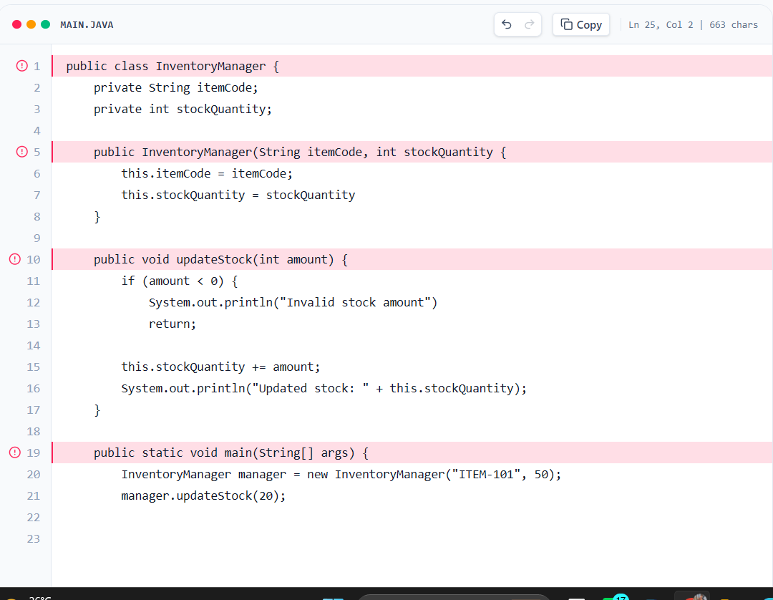
Figure 4.1 : Faulty Java source code used in the demonstration
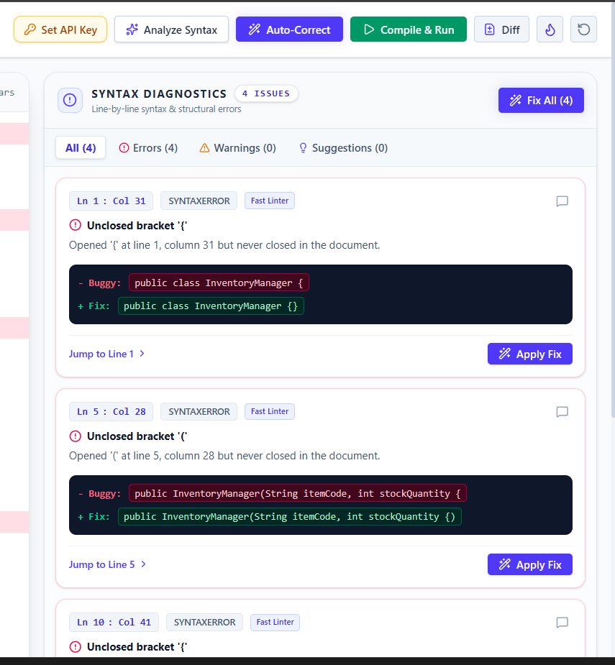
Figure 4.2 Syntax diagnostics and suggested fixes in the implemented interface
4.3 Test Plan & Verification
The test plan was defined around the project's functional requirements before interpreting the observed results. Tests use controlled source snippets containing known faults so that the expected diagnostic behaviour can be compared with the application output. Because no labelled benchmark corpus was included in the project archive, the report does not claim statistical precision, recall or correction accuracy percentages.
Requirement | Test Method | Acceptance Criterion
Local bracket detection | Enter source with an unmatched opening/closing bracket. | Diagnostic identifies the bracket problem with source location.
Unclosed string detection | Enter source containing an unterminated string. | Diagnostic reports the unclosed string.
Language heuristic | Enter a supported language with a targeted heuristic fault. | Relevant diagnostic is generated.
AI syntax analysis | Select Analyze Syntax with Gemini API configured. | Structured diagnostics appear in the error panel.
Auto-correction | Select Auto-Correct on a faulty source. | Corrected source and change summary are returned.
Diff review | Open correction result. | Original and corrected code are visibly comparable.
Apply Fix | Select an individual suggested fix. | Selected source change is applied to the editor.
AI Tutor | Ask a question about current code/error. | Contextual response is displayed.
Execution / preview | Select Compile & Run on supported modes. | Output, preview or simulation result is displayed.
Table 4.3 : Test Plan & Verification
Specification-wise Results
Specification | Required Value | Achieved Value | Status (Pass/Fail)
Interactive source editor | Working editor | Implemented with line numbers, markers, cursor and history | Pass
Language selection | Multiple modes | Ten selectable language modes | Pass
Local syntax diagnostics | Common structural errors | Bracket/string checks + language heuristics | Pass
AI analysis | Contextual structured diagnostics | Gemini endpoint with JSON schema | Pass*
Auto-correction | Corrected source + changes | Gemini endpoint + Diff Viewer | Pass*
Correction review | Review before applying | Diff Viewer + Apply Fix / Fix All | Pass
Demonstration evidence | Faulty Java example | Four issues visible in supplied demo interface | Pass
Native compilation for all modes | Actual compiler invocation | Not implemented; non-JS path is AI simulation | Not Achieved
Table 4.4 : Specification-wise Results
*AI-related tests require a configured Gemini API key and service availability.
4.4 Results
The submitted demonstration shows a faulty Java InventoryManager program inside the implemented editor. The corresponding diagnostics screen reports four issues and provides location-aware error cards together with suggested fixes and Apply Fix actions. This is direct qualitative evidence of the integrated error-reporting workflow.
The results also show that the interface does not depend exclusively on AI for its basic operation. The local diagnostic layer can identify structural problems independently, while the AI layer adds contextual reasoning when configured. The correction path can be reviewed through the Diff Viewer, which is important because AI-generated repairs are not guaranteed to preserve intent in every case.
4.5 Data Analysis & Engineering Judgment
The available project evidence is primarily functional rather than statistical. The demonstration confirms the presence of four visible issues for the supplied faulty Java example, but a single example cannot establish general accuracy. A statistically meaningful evaluation would require a labelled dataset containing a large number of valid programs, invalid programs, error categories, expected locations and reference corrections. Such a dataset was not included, so precision, recall, F1 score and correction success rate are intentionally not fabricated in this report.
From an engineering perspective, the hybrid architecture is the most significant result. Local checks are deterministic and inexpensive for common structural errors, whereas the AI service provides broader contextual interpretation. The disadvantage is that AI results depend on external service availability and can be non-deterministic. The use of structured responses and a human review step reduces, but does not eliminate, this risk.
4.6 Comparison with Existing Solutions & Achievement of Objectives
Objective | Evidence | Achievement (Fully/Partially/Not Achieved)
Design interactive compiler-oriented interface | React editor, language selector, diagnostics and actions | Fully Achieved
Implement local syntax-oriented checking | localLinter.ts with structural and heuristic checks | Fully Achieved
Integrate AI error analysis | /api/analyze-syntax using Gemini 2.5 Flash | Fully Achieved*
Implement auto-correction | /api/auto-correct and Diff Viewer | Fully Achieved*
Provide understandable feedback | Error descriptions, suggested fixes and AI Tutor | Fully Achieved*
Validate prototype | Controlled fault tests and demonstration evidence | Fully Achieved at prototype level
Provide native multi-language compilation | No native compiler processes in implementation | Not Achieved; documented boundary
Table 4.5 : Objective Achievement

*AI-dependent objectives require API availability and configuration.
4.7 Strengths & Limitations
Strengths:
- Hybrid design combines fast local checking with contextual AI assistance.
- Diagnostics contain structured location and explanatory information.
- AI-generated changes can be reviewed in a Diff Viewer before application.
- Component separation improves maintainability and UI clarity.
- API credentials are handled on the backend rather than intentionally exposed in the browser.
- Local diagnostics remain useful without an AI key.
Limitations:
- The local analyzer is heuristic-based and is not a complete lexer, parser or AST pipeline.
- AI suggestions can be incorrect, incomplete or broader than the intended fix.
- Non-JavaScript execution is AI simulation rather than native compilation.
- Client-side JavaScript execution is lightweight and not a hardened security sandbox.
- No persistent database, authentication, collaborative workspace or project history storage is implemented.
- No benchmark dataset or quantitative accuracy evaluation is included.
- The conceptual architecture shown in the presentation contains elements such as a training dataset/language database that are not separate implemented components in the submitted prototype.
4.8 Project Planning, Roles & Budget
Milestone | Planned Activity | Primary Responsibility | Evidence / Deliverable
1 | Problem definition, requirements and literature review | Both | Project problem statement and review
2 | Module 1 local syntax checking | Selva Prabhu A K | localLinter and diagnostic workflow
3 | Module 2 AI integration and correction | K Avinash | server endpoints and AI workflow
4 | Frontend/backend integration | Both | Working integrated application
5 | Functional testing and demo preparation | Both | Test cases and screenshots
6 | Report preparation and final review | Both | Final capstone report
Table 4.6 : Project Milestones

Student | Assigned Responsibility | Actual Contribution
Selva Prabhu A K (192421224) | Module 1 – Lexical & Syntax Analysis | Local syntax-oriented analysis, diagnostic integration, testing and related documentation.
K Avinash (192411044) | Module 2 – AI Error Detection & Auto Correction | Gemini integration, correction workflow, diff/tutor integration, testing and related documentation.
Table 4.7 : Project Roles and Contribution

Item | Estimated Cost | Actual Cost
Development computer | Existing resource | ₹0 additional
React / Node.js / Vite / Express / open-source libraries | Open-source | ₹0
Gemini API | Usage dependent | Not recorded
Internet connection | Existing resource | Not recorded
Total additional project cost | — | ₹0 excluding optional API usage charges
Table 4.8 : Project Budget

CHAPTER 5
CONCLUSION, FUTURE WORK AND REFLECTION
5.1 Conclusion
The Smart Compiler with AI-Based Syntax Error Detection and Auto Correction demonstrates an integrated approach to improving compiler feedback through the combination of deterministic local checking and AI-assisted reasoning. The engineering problem was to move beyond short syntax messages and provide a workflow in which errors can be located, explained, corrected and reviewed within the same application.
The project achieved its main prototype objectives. Module 1 provides local syntax-oriented diagnostics for common structural faults, while Module 2 uses Gemini 2.5 Flash to generate contextual diagnostics, explanations and candidate corrections. The frontend presents these results through an interactive editor, error panel, Diff Viewer and AI Tutor. The supplied Java InventoryManager demonstration reports four visible issues, providing functional evidence that the intended diagnostic workflow is operational.
The project also identifies the boundary between a compiler and a compiler-assistance prototype. The current local checker is not a complete language parser, and the non-JavaScript execution endpoint simulates execution through the AI service rather than invoking native compiler toolchains. These limitations do not invalidate the prototype; instead, they define the engineering scope and provide clear directions for future development.
5.2 Future Work
- Implement formal lexical analysis and grammar-based parsing for each target language.
- Build AST representations so that diagnostics can distinguish syntax, semantic and structural problems more reliably.
- Integrate real compiler/interpreter toolchains through isolated server-side execution.
- Introduce hardened container or sandbox execution for untrusted source code.
- Add persistent project storage, user accounts, project history and collaborative features.
- Create a labelled benchmark dataset containing valid/invalid programs, error locations and reference corrections.
- Measure precision, recall, correction success rate, response latency and false-positive rate.
- Add confidence scores and automated validation of AI-generated patches before they are offered to users.
- Support privacy-preserving or locally hosted AI options for confidential source code.
- Add language-specific formatting, semantic diagnostics and automated regression testing.
5.3 Professional Learning & Individual Reflection
New Knowledge Acquired
- Compiler-oriented concepts including lexical context, syntax checking, diagnostic locations and error recovery considerations.
- Design of a hybrid deterministic + AI software architecture.
- REST-style API integration between a React frontend and Express backend.
- Structured AI output using JSON schemas.
- Diff-based review for AI-generated code changes.
- Testing and reporting practices that distinguish measured evidence from assumptions.
Engineering & Professional Skills Developed
- Requirements analysis and decomposition of a complex software problem into modules.
- Modular interface and backend design.
- Integration of external services with controlled data formats.
- Functional testing using intentionally injected faults.
- Risk identification involving AI correctness, privacy, API availability and code execution.
- Technical documentation and transparent reporting of project limitations.
- Team collaboration through explicit module ownership and integration responsibilities.
Individual Reflection – Selva Prabhu A K (192421224)
My primary responsibility in this project was Module 1 – Lexical & Syntax Analysis. The most difficult engineering problem was creating useful syntax feedback without implementing a complete parser for every supported language. I addressed this by using a lightweight local scan with bracket tracking, string checks, comment awareness and selected language heuristics. A key decision was to keep the basic diagnostic path local so that common errors could still be detected when the AI service was unavailable. Through this work I developed a better understanding of how compiler concepts can be converted into practical software components. If the project were repeated, I would extend the module with formal tokenization and AST-based parsing so that the diagnostics become more language-aware and less heuristic.

REFERENCES

[1] A. V. Aho, M. S. Lam, R. Sethi, and J. D. Ullman, Compilers: Principles, Techniques, and Tools, 2nd ed. Boston, MA, USA: Pearson, 2006/2011.
[2] K. D. Cooper and L. Torczon, Engineering a Compiler, 3rd ed. Cambridge, MA, USA: Morgan Kaufmann, 2022.
[3] Meta Open Source, “Your First Component,” React Documentation. Accessed: Sep. 5, 2026.
[4] Vite, “Getting Started,” Vite Documentation. Accessed: Sep. 5, 2026.
[5] Google AI for Developers, “Structured outputs,” Gemini API Documentation. Accessed: Sep. 5, 2026.
[6] Google AI for Developers, “Generate content with the Gemini API,” Gemini API Documentation. Accessed: Sep. 5, 2026.
[7] OWASP Foundation, OWASP Top 10:2021, Open Web Application Security Project, 2021.
[8] International Organization for Standardization, ISO/IEC 25010:2023, Systems and software engineering — Systems and software Quality Requirements and Evaluation (SQuaRE) — Product quality model, 2023.
[9] K. Beck et al., “Manifesto for Agile Software Development,” Agile Alliance, 2001.
[10] Project source code, “Smart Compiler with AI-Based Syntax Error Detection and Auto Correction,” submitted implementation archive, 2026.
[11] Project presentation, “Smart Compiler with AI-Based Syntax Error Detection and Auto Correction,” Review 1 presentation, 2026.

APPENDICES
Appendix A – Detailed Calculations
The dominant local analysis operation is sequential source scanning. Let n represent the number of characters in the source and b represent the maximum number of simultaneously unmatched opening brackets. A single-pass scan requires approximately O(n) time and O(b) auxiliary memory for delimiter tracking. Additional heuristic checks remain small relative to the source length. The AI path does not have a fixed application-side complexity because model processing and network latency depend on the external service.
Metric | Expression / Basis | Interpretation
Local scan time | O(n) | Grows approximately linearly with source size.
Bracket stack memory | O(b) | Depends on maximum nesting depth.
AI request count | Depends on user actions | Analyze, Auto-Correct, Explain and Chat trigger separate requests.
Request body limit | 5 MB | Prevents excessively large JSON requests.
API latency | External-service dependent | Affected by network and model service.
Correction validation | Human review | Diff Viewer provides practical verification before apply.
Table 5 : Engineering Complexity Analysis
Appendix B – Engineering Drawings / Schematics
The main architecture and workflow diagrams are included in Chapter 3. They represent the actual implemented software structure rather than the conceptual presentation-only elements that were not found as independent components in the submitted source archive.
Appendix C – Source Code / Code Repository Information
The submitted implementation archive contains the main React, TypeScript, CSS, Express server, preset data, linter and configuration files. Important files include App.tsx, CodeEditor.tsx, ErrorPanel.tsx, DiffViewer.tsx, ExecutionTerminal.tsx, AiTutorDrawer.tsx, Header.tsx, PresetSelectorModal.tsx, localLinter.ts, types.ts, presetSnippets.ts, server.ts, package.json, tsconfig.json and Vite configuration.
Appendix D – Datasheets
No physical hardware or electronic component datasheets are applicable because the project is a software-only prototype. Relevant software and API documentation is listed in the References section.
Appendix E – Experimental / Raw Data
The project materials provide demonstration screenshots rather than a large raw experimental dataset. The supplied faulty Java demonstration is therefore treated as qualitative functional evidence. Future quantitative evaluation should record test-case identifiers, source code, injected fault, expected error, observed error, correction correctness, response latency and pass/fail status.
Appendix F – Ethics / Institutional Approval
No human-subject experiment, medical intervention, physical hazard or sensitive personal dataset is part of the submitted prototype. The main ethical considerations concern responsible disclosure of AI use, avoiding fabricated performance claims, protecting API credentials and warning users that external AI analysis may transmit source code.
Appendix G – Project Meeting / Progress Records
The project was progressed through problem definition, literature review, Module 1 implementation, Module 2 AI integration, frontend/backend integration, functional testing and report preparation. Specific meeting dates, attendance records and faculty signatures should be appended by the team if required by the department.
Appendix H – User / Industry Feedback
No formal industry feedback dataset was included in the submitted materials. Evaluation is therefore based on prototype demonstration and functional verification. If faculty or user feedback is collected during the final demonstration, the comments and resulting design changes can be added here.
Appendix I – Publications / Patents / Competitions / Product Outcomes
No publication, patent, competition award or commercial product outcome is claimed for this project at the time of report preparation.
Appendix J – Individual Contribution Evidence
Selva Prabhu A K (192421224) is the primary contributor for Module 1 – Lexical & Syntax Analysis. K Avinash (192411044) is the primary contributor for Module 2 – AI-Based Error Detection & Auto Correction. Their responsibilities, development contribution, testing contribution and report contribution are documented in the Individual Contribution Statement and Chapter 4.

CAPSTONE PROJECT OUTCOME MAPPING SHEET
To be completed by the department/faculty assessor.
Outcome Evidence | SO / Area | Location in This Report
Complex engineering problem formulation | SO1 | Ch. 1, Ch. 2
Engineering design under constraints | SO2 | Ch. 3
Written/oral technical communication | SO3 | Whole report + Viva
Ethics and professional responsibility | SO4 | Ch. 3 (3.7)
Teamwork and leadership | SO5 | Ch. 4 (4.8)
Experimentation, analysis, engineering judgment | SO6 | Ch. 4 (4.3–4.6)
Independent acquisition of new knowledge | SO7 | Ch. 5 (5.3)
Standards | SO2 | Ch. 3 (3.2)
Sustainability and societal/environmental impact | SO2/SO4 | Ch. 3 (3.7)
Risk assessment and mitigation | SO2/SO4 | Ch. 3 (3.7)
Security considerations | Relevant SO | Ch. 3 (3.7)
Integrated/system-level engineering | SO1/SO2 | Ch. 3 (3.5)
Project planning and management | SO5 | Ch. 4 (4.8)
Individual contribution | SO1–SO7 | Contribution Statement + Ch. 4 (4.8)

